Annual Meeting Information
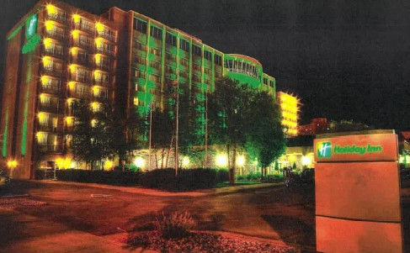
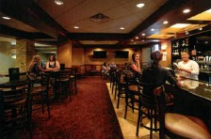

February 22-24, 2022
Sioux Falls, SD
Holiday Inn, Sioux Falls – City Centre

Social at the Holiday Inn Lounge and Banquet at the Holiday Inn Starlite Ballroom

Registration Costs (Feb 4, 2022 deadline)
Professional: $150
Student: $120

Late-registration fees are $170 professionals; $140 students

Call the Holiday Inn – City Centre at 605.339.2000 to make a reservation. Seventy-five rooms will be held through January 21st. Make sure you mention the Dakota Chapter of the American Fisheries Society Meeting when making your reservation to receive a discounted rate. State and Federal rates will apply. Bring your work ID!

Registration link: https://dakota.fisheries.org/ninja-forms/5o94n/

Annual Meeting Plenary Session: Mike Hawkins, Fisheries Biologist, Iowa DNR

Mike will share his experience with Iowa’s successful long-term project to convert 1,200 acre Lost Island Lake in NW Iowa from a turbid water to clear water state by using a multi-faceted approach to reduce the abundance of common carp and other rough fish.

