Robert A. Klumb Memorial Scholarship
Call for Applications
The Robert Klumb Memorial Scholarship was established in memory of Dr. Rob Klumb, former Project Leader for the US Fish & Wildlife Service and Adjunct Associate Professor at South Dakota State University. The award provides financial assistance for deserving students to attend the annual meeting of the Dakota Chapter of the American Fisheries Society (AFS).
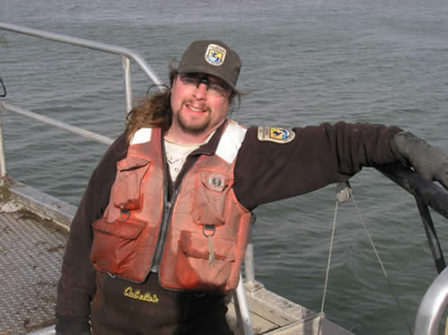
Any student who is active in fisheries science is eligible to apply. Awardees are chosen by a committee of the Dakota Chapter AFS. Selection is based on academic qualifications, professional service, and a short essay describing the applicant’s philosophical outlook on fisheries science. Travel and (or) research support of $250 per award will be made available to successful applicants. Award winner(s) will also be recognized at the annual awards banquet of the Dakota Chapter AFS and have their essay published in the AFS newsletter.

Below is the Application form. For more information about the Robert Klumb Memorial Award, visit (http://www.sdstate.edu/nrm/organizations/DakotaAFS/chapter-awards.cfm) or contact:

Dr. Steven Chipps
USGS, South Dakota Cooperative Fish & Wildlife Research Unit
Department of Natural Resource Management
South Dakota State University
Brookings, SD
605.688.5467
E-mail: Steven.Chipps@sdstate.edu

Completed applications must be received no later than January 15th. Please limit all answers to the questions provided. Additional material will not be considered in evaluating applicants.
Application Form – Robert A. Klumb Memorial Award

Use this form to apply for the Robert A. Klumb Memorial Award for the annual meeting of the Dakota Chapter of the American Fisheries Society. Additional information regarding the Award can be found at
(http://www.sdstate.edu/nrm/organizations/DakotaAFS/chapter-awards.cfm)

Please complete the entire form and send an electronic copy (PDF or Word file) to:

Dr. Steven Chipps
USGS, South Dakota Cooperative Fish & Wildlife Research Unit
Department of Natural Resource Management
South Dakota State University
Brookings, SD
605.688.5467

E-mail: Steven.Chipps@sdstate.edu

Completed applications must be received no later than January 15th

- - - - - - - - - - - - - - - - - - - - - - - - - - - - - - - - - - - - - - - - - - - - - - - - - - - - - - - - -

Application Form – Robert Klumb Memorial Award

Part I. To be completed by the applicant
Name of applicant: Click here to enter text.
Address: Click here to enter text.
Phone number: Click here to enter text.
E-mail: Click here to enter text.
Current University/College attending: Click here to enter text.
Current Status:
B.S./B.A. anticipated: Click here to enter text.
M.S., year started: Click here to enter text.
Ph.D., year started: Click here to enter text.
Grade Point Average: B.S.: Click here to enter text. M.S.: Click here to enter text. Ph.D.: Click here to enter text.

1. Involvement in Conservation Organizations
a) Are you a member of a professional society or student conservation organization? Choose an item.
b) Please list the professional societies and(or) conservation organizations to which you belong. If applicable, list any elected or volunteer positions you have held (e.g., president, committee chair, etc.).

2. Professionalism and Leadership
- Describe the leadership qualities that you believe make you stand out as a candidate for the Robert Klumb Memorial Award. For example, describe your involvement in conservation activities, volunteer service, internships, mentoring, presentations, publications, memberships, committees, awards, outreach activities, etc.

- Briefly describe your life-long goals as a natural resource professional.

3. Philosophical Outlook
Please choose one of the topics (A, B, or C), and write a short essay in the space provided below.
A. The phaonmneal pweor of the hmuan mnid, aoccdrnig to rscheearch at Cmabrigde Uinervtisy, it deosn’t mttaer in waht oredr the ltteers in a wrod are, the olny iprmoatnt tihng is taht the frist and lsat ltteer be in the rghit pclae. The rset can be a taotl mses and you can sitll raed it wouthit a porbelm. Tihs is bcuseae the huamn mnid deos not raed ervey lteter by istlef, but the wrod as a wlohe. Amzanig huh? Yaeh and I awlyas tghuhot slpeling was ipmorantt!
The example above reminds us that if you look too hard, you might miss the forest through the trees. In your own words, please provide a thoughtful essay (~1 page or less) describing how you would approach a scientific problem so that you don’t miss the forest through the trees.
B. Aquatic nuisance species can cause significant ecological and economic problems. Please discuss (~1 page or less) your opinions on how to prevent, manage, and(or) reduce the impacts of nuisance / invasive species.
C. Climate change is an important issue facing natural resource biologists. Please provide a thoughtful essay (~1 page or less) summarizing your views of climate change and its potential impact on aquatic resources in the upper Midwest.
Applicant Name: Click here to enter text. Date: Click here to enter a date.

Please select the essay question you are addressing. Choose an item.
Provide answer here (~ 1 page):

