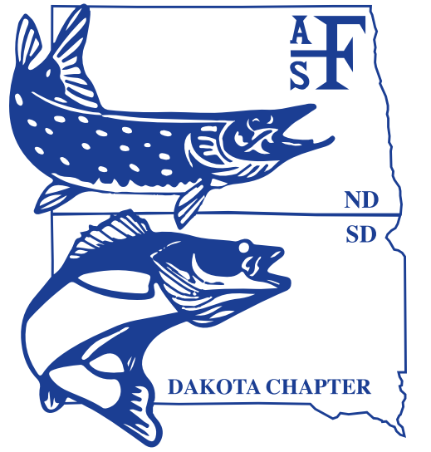

**Dakota Chapter**

**American Fisheries Society**

*Business Meeting*

*Brookings, South Dakota*

*Tuesday, February 27; 4:00 pm  
Days Inn Convention Center – room C/D*

I. Call to Order

II. Introduction of Guests

III. Determination of a Quorum

IV. Approval of Agenda

V. Approval of Minutes from 2017 Business Meeting

VI. President’s Comments

VII. Treasurer’s Report

VIII. Comments by AFS Officer (Mark Pyron, President – AFS NCD)

IX. Committee Reports

1. Awards and Nominations (Casey Williams, Past-President)
2. Continuing Education (Daniel James, Chair)
3. Environmental Concerns (Geno Adams, Co-chair)
4. Information and web support (Hilary Meyer, Chair)
5. Membership (Matt Ward, Chair)
6. Planning (Josh Wert, President Elect)
7. Program (Mike Smith, Vice President)
8. Resolutions (Chelsey Pasbrig, Chair)
9. Student Affairs
   1. SDSU Sub-unit (Travis Rehm, President)
   2. VCSU Sub-unit (Morgan Berquist, President)

X. Special Committees

A. Centrarchid Technical Committee (Nick Kludt, Chair)

B. Esocid Technical Committee (Brian Blackwell, Chair)

C. Ictalurid Technical Committee (Dave Lucchesi, Chair)

D. Rivers and Streams Technical Committee (Nick Kludt, member)

E. Walleye Technical Committee, (Mark Fincel, Todd Caspers, Co-chairs)

XI. Additional Reports

XIII. Old business

XIV. New business and announcements

XV. Adjournment