**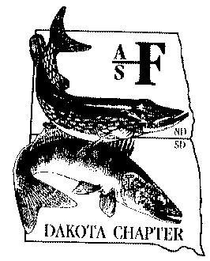****Dakota Chapter**

American Fisheries Society

**Newsletter**

**Issue 54 November 2015**

**President’s Message**

***Highlights in This Issue***

***President’s Message.........................1***

***2015 Business & ExComm Meeting minutes……………...……….…..........2***

***North Dakota Fisheries Update……4***

***South Dakota Fisheries Update…...5***

***Esocid updates…………………….…8***

***SDSU Subunit Update…………….…9***

***VCSU Subunit Update……………...10***

***Dakota Chapter 2016 Meeting Announcement………………………11***

***Dakota Chapter Award Nominations Request……………………………….13***

***Meetings and upcoming events.....14***

***Chapter contact info……………......17***

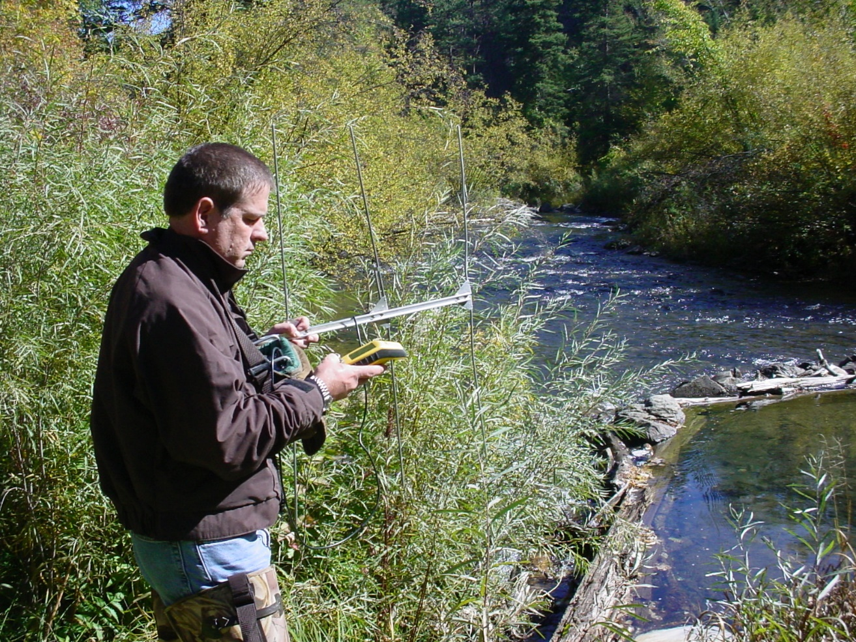

I trust that this communication finds all of our fellow fisheries folks in pleasant conditions. We, currently, appear to be in a good climatically wet pattern, which allows lakes to be full and streams to flow. It would be nice for us to always have these conditions, but those of us who have lived in the Dakota’s long know that these patterns will certainly change.

What will the future hold? I am stimulated to focus on the future when I was privileged to hold my first grandchild for the first time. Beyond the comprehension of holding a new generation, it also provided me with the chance to reflect on what opportunities he will have in his life that were not foreseen just one generation earlier. But let’s be honest, there will be changes to our environment, jobs and stability that will change how we look at things. I don’t plan to be a fortune teller, but I believe with strong management skills we can overcome challenges that normally fill in to each of our areas.

Currently, some of us are dealing with the effects of oil exploration in their backyard. Others “get” to be involved with tiling of wetlands that are converting to farmland. Some of our current challenges involve issues on more of a watershed scale and can affect our fisheries in a number of ways. In South Dakota, Governor Dugaard held a Pheasant Summit where several recommendations were geared towards conservation and a certification process for landowners. The impacts of these efforts are yet to be seen, however, we should be consistent and vigilant in our efforts for conservation in these areas as they will ultimately aid the fisheries as well. Our past shows how we have been successful.

In 2014, the Dakota Chapter celebrated our 50th year. We were not alone in this achievement as the North Dakota Chapter of the Wildlife Society was also rejoicing a similar accomplishment. However, it did give people a chance to reflect on where were are and what the future holds. There is more information in regards to this topic later in the newsletter (look for flyer on a forthcoming symposium). This would be a great chance to learn from a leader in the field of communications.

Lastly, I would like to put in a blatantly shameful request to all members. Each year we are faced with a similar need from members and this year will be no different. The chapter is always in need of assistance in members to step up and be an active part of the Dakota Chapter. We have several committees that could use the help. For many years, I was involved in the Resolutions Committee and now have the chance to look back and see how this small part had an important impact on our chapter. Please consider volunteering your time and efforts to make our chapter better and contribute to conservation in the Dakota’s.

Greg Simpson President

**2015 Fall Excom Meeting**

**Dakota Chapter**

**American Fisheries Society**

**September 9, 2015**

**9:00 AM**

President Kurt Eversman called the meeting (conference call) to order at 9:00 am. Ex Com members present in attendance were Kurt Eversman, Todd Caspers, Zac Sadness and Greg Simpson. Also in attendance were Casey Williams and Jake Davis.

**Presidents Report (Kurt Eversman).**

Just a few items to discuss since the meeting last February. I worked with Greg on the Spring/Summer newsletter. I had several members express interest in receiving feedback/comments from our judges on their poster/oral presentations. Additionally, I received positive feedback about our February meeting in Bismarck – well done to those involved.

**Vice Presidents Report (Todd Caspers).**

Final numbers from the 2015 annual meeting were great. Todd mentioned that he received a lot of positive feedback from the meeting.

**Secretary/Treasurer Report (Zac Sadness).**

Account balances as of 9/08/15: U.S. Bank checking account $12,689, the Edward Jones account $6,401.10, the Robert Klum account $7,112.19 and the Schmulbach account $11,598.24.

**President Elect Report (Greg Simpson).**

Greg said plans are coming along well with the coordination of the hotel and venue for the 2016 annual meeting. The dates of the meeting are February 1st-3rd in Spearfish, SD. The 1st would be the date for any continuing ed workshop (working with Dan James to finalize this). A social/mixer would be held the evening of the 1st sponsored by the Student sub-unit. The social/mixer will be held on the evening of February 1st. The venue for the social/mix has yet to be determined.

**SDSU Student Sub-Unit** **(Nothing to report).**

.

**VCSU Student Sub-Unit** **(Casey Williams).**

The sub-unit is working on getting membership up. Currently they have 23 paid members. Last year they had 26 paid members. The sub-unit is planning to have a fishing contest this fall to generate interest and encourage new membership. There seems to be a lot of interest from incoming freshman.

**Committee Reports (Nothing to report)**

**Old Business (Nothing to report)**

**New Business**

Kurt welcomed new Ex Com members (Casey Williams, Jill Voorhees, Jake Davis) and thanked Kurt Eversman, Todd Caspers and Zac Sadness for their work on behalf of the Chapter.

Kurt discussed a request from Royce Meritt, with Dakota Trout Unlimited, who’s interested in working with our organization to develop/restore Gary Creek in South Dakota. Dakota Trout Unlimited wants our help to develop Gary Creek into a viable trout fishery. He was specifically interested in talking with our members in South Dakota to discuss the details. Greg Simpson is going to work with Royce Meritt to brainstorm ways that the Chapter could assist with Dakota Trout Unlimited on this project.

Kurt discussed a request from Vince Travnichek, with the North Central Division American Fisheries Society, about updating our current officer list for their records.

Kurt discussed transferring the point of contact information of the Edward Jones account from the current President to either the incoming President or Secretary/Treasurer. It was decided that

the point of contact for the account will remain with whoever is the current President until voted on by our membership during the annual meeting.

The board briefly discussed extending the term for the Secretary/Treasurer from one year to two years to better serve the chapter’s needs. No official vote occurred and it was recommended that we bring the abovementioned up for discussion and/or a vote during our annual meeting.

Greg mentioned that Dan James has agreed to replace Steve Chips as the Continuing Education Committee chair.

Greg mentioned that Hilary Meyer has been doing a wonderful job with keeping our website updated.

The meeting was adjourned at 10:12 a.m.

We can now accept **membership dues online** via pay pal.  Just go to the Dakota chapter AFS website : <http://dakota.fisheries.org/membership/> to renew or join today.  Any website updates can be sent to: [Hilary.Meyer@state.sd.us](mailto:Hilary.Meyer@state.sd.us)

**North Dakota Fisheries Update**

After another couple years of record water on the landscape, dry conditions and declining water levels the past few months remind us of the extremes when living, working and playing in the Dakotas. Despite this significant ‘drying out’ of late, records continue to be set in regards to ‘all things fishing’. Currently there are approximately 420 fishable water bodies in North Dakota compared to less than 170 lakes 25 years ago. Due to a record number of fishing lakes and aggressive fish management, a historic number of fishing licenses are being purchased. In 2014-15, 222,000 (157k resident and 65k non-resident) fishing licenses were sold which is an all-time record. Lake Sakakawea, Devils Lake and Lake Oahe/Missouri River remain as the top three fisheries in the state.

Trying to keep up with development matters (e.g. boat ramps) and addressing the myriad of Aquatic Nuisance Species issues continue to receive a lot of attention in North Dakota. This has proven to be very challenging given limited resources but fortunately top-notch staff have kept our heads above water (barely). In addition, management staff continue to try to keep up with routine tasks such as population surveys which in itself has been a chore given the growing number of waters each year, esp. again given our small, finite staff.

Although in the short term great fishing opportunities await the fishing public, biologists continue to be concerned about a prolonged drought period. We all know all too well what the lack of water means to our profession. In the broader picture, ongoing habitat degradation to our lakes due to grassland conversion and the lack of implementing best (conservation) management practices is of grave concern. Fisheries managers in the plain states have always stressed and pushed for maintaining water quality of our fishing waters by improving the condition of the respective watersheds. Unfortunately, just a short drive in rural Dakota will quickly provide all with an unhealthy visual and reinforce the fact that the current USDA farm bill has not been fish habitat friendly.

Concerns about drought, farming practices, oil/brine spills, the list goes on, are enough to keep most biologists awake at night.  Yet, if you factor in the strong work ethic of North and South Dakota resource managers, which offsets some of these worries, the Dakotas still have plenty to offer in terms of fishing opportunities and quality fisheries.  As always, it’s refreshing to spend a few days in the field to observe firsthand the level of dedication and commitment of our fishery resource professionals.

In the immediate future, there’s a lot to look forward to with the hard water season only a month or so away. Make it a priority and get out and wet a line. Good luck.

Submitted by Greg Power

**South Dakota Game, Fish and Parks Fisheries Program Update**

**New Fisheries Program Structure**

A major change in the fisheries program structure was implemented in early August and resulted in all staff working in fisheries or aquatics resources being placed in the Aquatics Section of the Wildlife Division. Prior to the change, staff were divided between the Aquatics Section and four geographical regions. The Missouri River program, state hatcheries, and fisheries biologists were part of the Aquatics Section and each region had a fisheries program manager and a fisheries crew as part of the region structure, supervised by a regional supervisor. This is the first time that the fisheries staff have all been within one chain of command within the Wildlife Division. Benefits of the reorganization include more direct lines of supervision for all staff within a work area, more direct lines of supervision between the management and research program administrator and area fisheries supervisors, and a more efficient, statewide approach to utilizing budget, equipment, and personnel resources.

Under the new structure, Geno Adams, the program administrator for management and research, supervises five area fisheries supervisors (AFS) which are stationed in Sioux Falls, Webster, Chamberlain, Ft. Pierre, and Rapid City. All fisheries staff at each of these offices is supervised by the AFS and staff in Yankton and Mobridge are supervised by the AFS in Chamberlain and Ft. Pierre, respectively. Chelsey Pasbrig, the non-game aquatic biologist, is directly supervised by Geno.

Will Sayler, the program administrator for production and development, supervises the state hatchery system, the aquatic invasive species program, and environmental review and permitting.

It will take some time to iron out any rough spots in staff duties, authorities, or coordination resulting from the new structure but I am excited about the opportunities this change provides to be more efficient and more effective at managing the fisheries and aquatic resources of South Dakota.

**SDGFP Staff Changes**

Dylan Jones, a resource biologist in the Rapid City office, resigned his position to take over the family farm. Plans are to fill that position this fall and upgrade the position from a resource biologist to a wildlife (fisheries) biologist. A vacancy at Blue Dog State Fish Hatchery, created when conservation technician Gene Holm retired last spring, will be filled as a resource biologist this fall.

Submitted by: John Lott, Aquatics Section Chief

**South Dakota Percid updates 2015**

Spawning:

During 2015, a total of 75.7 million walleye eggs were collected from 9 South Dakota Lakes (I can get you the list of lakes if needed.) and this resulted in 36.1 million walleye fry (48% hatch) being stocked into South Dakota lakes or hatchery ponds.  Also, 7.1 million yellow perch eggs were collected which resulted in 4.5 million eyed eggs being available to either stock hatchery ponds, natural rearing ponds, or use to produced fry.  Yellow perch fry production attempts were unsuccessful during 2015.

Projects:

**Natal contribution and movement of walleye in Lake Sharpe, SD evaluated using otolith microchemistry.**

Previous microchemistry research pointed to North Shore, Fort George, and West Bend being the most important natal contributors to the Lake Sharpe walleye population. Current research suggests West Bend is the most important natal contributor, with all other sites contributing less than 8%. Also, entrainment in 2013 was 19% with 70% entrained during the flood. 2014 entrainment seems to have decreased to only 1%. Hipple Lake doesn’t seem to be important at any stage of Lake Sharpe walleyes’ life histories, but contributes to 20% of natal gizzard shad production.

**Lake Oahe walleye tagging**

Approximately 9,100 walleye were jaw tagged in 2015 with over 2,000 returns to date (as of July). This project is currently in its third (of five) years. We hope to answer many questions regarding the Lake Oahe walleye population but some highlights include: 1) what are movement patterns of Lake Oahe walleye, 2) what is mortality (natural and angling) of Lake Oahe walleye and 3) model the effects of different regulations on the Lake Oahe walleye population.

**Stocking Produces a Large Yellow Perch Year Class in Brant Lake, South Dakota**

In 2014, the stocking of 499,000 (500/acre) hatchery-reared yellow perch fingerlings (600-950/lb) into 987-acre Brant Lake has apparently produced a large year class. The lake was stocked due to several consecutive years of poor natural recruitment. About 75% of the fingerlings were OTC-marked so stocking contribution could be assessed.

More age-0 yellow perch were caught while beach seining Brant Lake than any of the other waters sampled last fall (see figure below). Bright OTC marks were present on the otoliths of 43 of 61 fish (70%) indicating a 93% stocking contribution.

The Brant Lake stocking represents our first success at producing a strong yellow perch year class in a large lake. Fingerling stocking has increased yellow perch abundance in some smaller waters 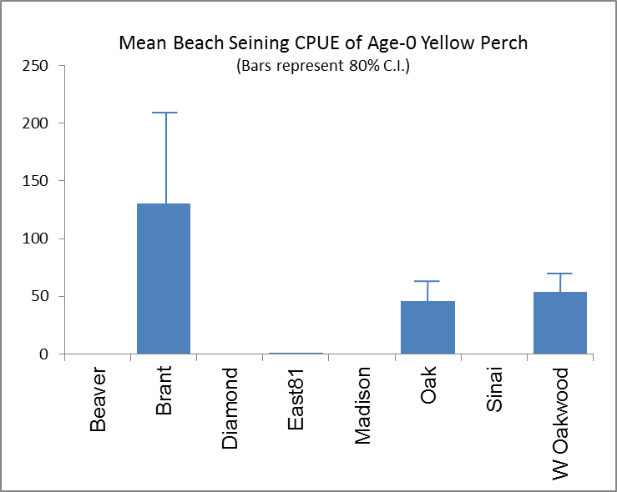(< 400 acres), but success has varied. The abundance of naturally-produced fish has often exceeded that of stocked fish. Additionally, the contribution of perch fry stocked into natural rearing ponds has also been negligible. Continued evaluation will be needed to ultimately determine whether yellow perch stocking can significantly improve fishing in South Dakota.

Submitted by Mark Fincel

**South Dakota AIS Update**

A single adult Zebra mussel was discovered by the South Dakota Department of Game, Fish and Parks (SDGFP) on a boat dock at Lewis and Clark Lake in November, 2014. After an extensive search following this discovery, no additional mussels were found. This event, in conjunction with a water sample from Angostura Reservoir identified as positive for Quagga mussels, led to the implementation of new administrative rules to slow the spread of Aquatic Invasive Species (AIS) in the state and increased monitoring efforts at both waterbodies.

Zebra mussels can begin to reproduce when water temperatures reach approximately 55°F, which typically occurs in May for most waters in South Dakota. Beginning in mid-May, monthly water samples from Lewis and Clark Lake were analyzed to determine if mussel larva were present. No veligers were found in May or June; however, a single zebra mussel veliger was identified in the July sample from the marina at Lewis and Clark State Recreation Area.

After multiple adult mussels were found attached to boats being serviced at the marina, SDGFP biologists suited up and performed a snorkel survey of 111 boats and dozens of dock structures. Zebra mussels were found to be attached to almost every dock structure and on approximately 1/3 of all boats in the marina. Subsequent sampling performed by SDGFP, the Nebraska Game and Parks Commission, the National Park Service and the Army Corps of Engineers has shown that although the population of mussels is relatively small, the geographic distribution is widespread. Mussels were found at almost every dock downstream of the Niobrara River Delta.

South Dakota Game, Fish & Parks is currently leading a workgroup of multiple city, state and federal agencies to determine the future course of action for Lewis and Clark Lake. The Administrative Rules in place in South Dakota were implemented prior to the discovery of the infestation and they continue to be essential to AIS prevention efforts. Enforcement of these rules and the use of SD Least Wanted outreach campaign will also increase significantly in the future to help slow the spread of AIS in South Dakota. For additional information, please visit [www.sdleastwanted.com](http://www.sdleastwanted.com).

Submitted by Mike Smith

**Dakota Chapter Esocid Report**

The 2015 summer Esocid Technical Committee (ETC) meeting was July 23at Dakota Nature Park in Brookings, South Dakota. The business meeting was held in conjunction with the joint Centrarchid, Walleye, and Esocid Technical Committees Meeting. Those present discussed a recent article (Muskellunge and Northern Pike Ecology and Management: Important Issues and Research Needs) in *Fisheries* which prompted the question, “Does the ETC need to address research questions/needs identified in the article?” Attending members were in general agreement that the role of the ETC is to facilitate the communication on issues surrounding esocids in the region. The ETC is not set up to directly participate or drive specific research questions. The idea of having the ETC provide letters of support for esocid research may be possible if that is requested by someone for a specific project. Sharing of ideas and results may be facilitated by having an on-line outlet through the ETC. The next ETC meeting will take place during the Hugh C. Becker Muskie Symposium in Minnetonka, Minnesota during March 2016 and not at the Midwest Fish and Wildlife Conference in Grand Rapids, Michigan.

The Hugh C. Becker Muskie Symposium will take place March 13-15, 2016 in Minnetonka, MN. Muskellunge researchers, resource managers, and anglers from across North America will gather for 3days of technical presentations, poster sessions, panel discussions, and great socials. The symposium is sponsored by MUSKIES, INC. and the ESD. This symposium will commemorate the 50th Anniversary of Muskies, Inc. Presentations and socials will be held at the Sheridan Minneapolis West, Minnetonka, MN; double occupancy rooms are $89. Early registration for the meeting will be available 10/15/2015–2/16/2016. There will be a reduced fee for students. Check Muskiesinc.org for information on arrangements and to register for the meeting. Lodging and Registration Fees will be waived for presenters. Plans are to publish the proceedings as a peer-reviewed AFS Special Publication. Abstracts for Presentations and Posters should be submitted to the Program Technical Committee, c/o: Dr. Derek Crane, Coastal Carolina University: [dcrane@coastal.edu](mailto:dcrane@coastal.edu). Deadline for submission of abstracts is December 31, 2015.

**Dakota Chapter Esocid Update**

Angler reports of muskellunge being caught from Lake Sinai (1,200 acres) in Brookings County began this spring. Muskellunge were first stocked into Lake Sinai in 2011. Many large northern pike were observed in southeast South Dakota waters during 2015 walleye spawning operations.

Muskellunge populations in northeast South Dakota were sampled during the 2015 spring at Amsden Dam (235 acres) and Lynn Lake (1,600 acres) using large trap nets. The Amsden Dam population was estimated at 18 individuals and 202 fish were estimated to be present in Lynn Lake. Muskellunge stocking in Amsden Dam will likely discontinue because of apparent low survival. Muskellunge were stocked into Middle Lynn Lake for the first time this fall. Middle Lynn Lake (740 acres) is adjacent to Lynn Lake and during a high water period some muskellunge moved into Middle Lynn Lake from Lynn Lake. A 46.5-inch muskellunge was harvested by an angler fishing Middle Lynn Lake in May 2015.

Research comparing muskellunge catches between two trap net designs in three South Dakota waters was recently published in *The Prairie Naturalist* (47:21-25).

Submitted by Brian Blackwell

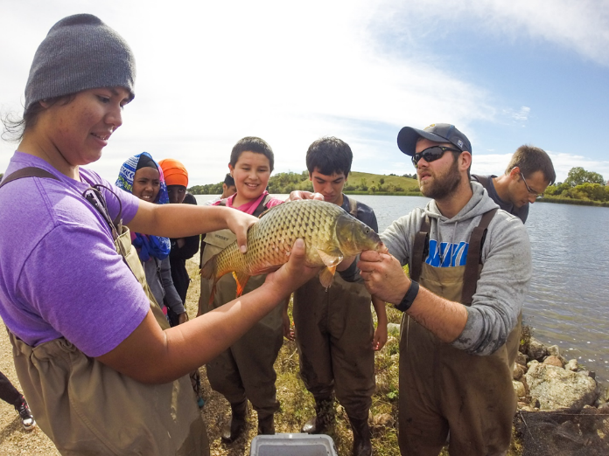

SDSU Subunit Upward Bound Field Trip with Dan Nelson and Chad Kaiser

**SDSU AFS Student Subunit Update**

The South Dakota State University (SDSU) American Fisheries Society Subunit has had a busy fall semester. We have been working hard to fulfill our goals of increasing membership, continuing education opportunities, outreach activities and professional development of student members. We are happy to announce that we have a new interim treasurer; Nicholas Kludt, a new fisheries PhD student, was elected early this fall. We are excited to have him on our team and look forward to his input and leadership.

The SDSU subunit successfully catered for the Walleye, Centrarchid, and Esocid Technical Committees meeting through the AFS North Central Division. It was a great occasion for new members and undergrads to take part in a meeting and see the camaraderie, professional development, and science – great benefits of an AFS membership. Future collaborations with University of Wisconsin- Stevens Point also stemmed from this occasion, so stay tuned.

Our subunit has also been busy with fisheries community outreach around the region. In September, the SDSU subunit participated in an outdoor field trip for the Brookings Mickelson Middle School at Dakota Nature Park in Brookings, SD.  General aspects of natural resources management were covered, with a focus on fish and fisheries in South Dakota. Over the course of two days, we worked with about 250 kids.  We also participated in an Upward Bound field trip to Oak Lake, SD, where we interacted with 40 under-privileged or first generation high school students. Both outreach activities were great opportunities for local middle and high school students to see what we do as fisheries biologists and to instruct on topics such as fisheries management, species diversity and fish ecology.

At the University, we have had a number of speakers during the fall semester. We held a bean bag tournament geared to fostering an environment of education. The event also served to open a platform where the undergraduate students had some one-on-one mentoring time with SDSU graduate students. We have been partnering with South Dakota GFP and Trout Unlimited through one of our chapter advisors, Dr. Chipps, to assess and develop strategies to reintroduce brown trout into Gary Creek, a local cold water stream and legacy project for Dr. Dave Willis. Most recently, the subunit was invited to the Whitlock Bay Salmon Spawning Station to help with Chinook fall spawning. We are very thankful to the SD GFP for the chance to learn more about South Dakota salmon management and the artificial spawning process used to support this unique fishery.

We are looking forward to the rest of the semester and will be electing new officers in December. Also in December, we will host our annual Chili feed and career fair here at SDSU. Please stay tuned for more information if you are looking to hire a technician or intern position, as either an employer or as a student employee!

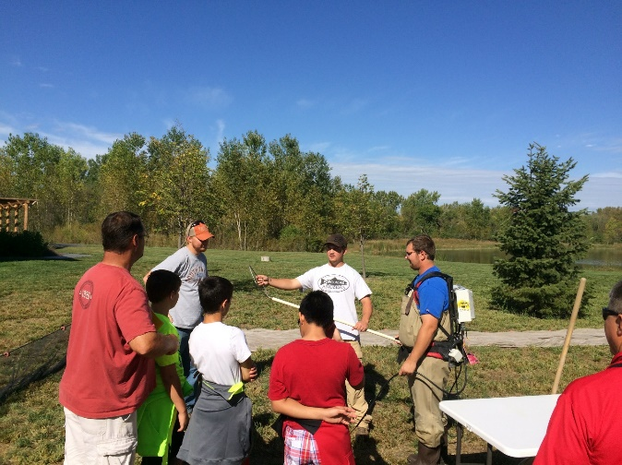SDSU Subunit Middle School field trip with Alex Rosburg, Chance Kirkeeng, and Dalton Benage

**VCSU AFS Student Subunit Update**

The VCSU Student Subunit is on its second year and doing very well with participation and membership, with a total of 31 undergraduate members. The Fall semester has been busy with events hosted by the subunit, including a Wild game/fish fry cookout, annual fishing scramble tournament, canoe and fishing trip, canoe races and a salmon fishing trip to Lake Sakakawea. Future event plans include a November Fisheries and Wildlife job fair at VCSU, guest speakers and ice fishing over the winter months. The fall fundraiser will be an Ice Fishing package raffle that includes an ice auger, ice house, and a fish finder - all for one lucky winner (for information or tickets, please contact Lane Dahl at <lane.d.dahl@vcsu.edu>). Also, we will host the annual gumbo feed during February. Club officers include: President- Lane Dahl, Vice President- Levi Fettig, Secretary/Treasurer- Cole Marvel, Fundraising- Alicia VanSweringen, Public Relations- Gage Metzen, with Casey Williams and Andre Delorme as club advisors.

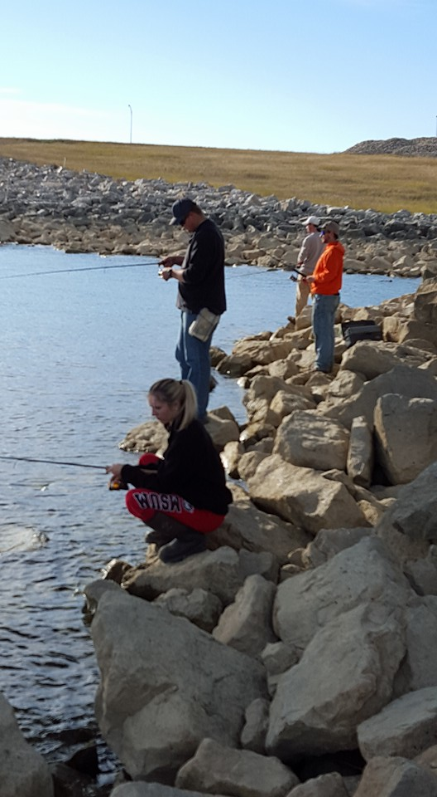

VCSU subunit members salmon fishing



**Annual Meeting Announcement**

**Dakota Chapter**

**of the**

**American Fisheries Society**

**February 1-3, 2016**

**Holiday Inn, Spearfish, SD**

Monday, February 1 – registration and welcoming social

Tuesday, February 2 – registration, papers and business meeting – **awards banquet in the evening**

Wednesday, Feb. 3 - papers, adjourn by noon.

**Make your reservations today!**

**Call the Holiday Inn directly at 605.642.1679 to make a reservation. Be sure to mention you are with Dakota Chapter AFS to ensure maximum benefits for the Chapter.**

**First Call for Papers**

**All Aquatic and Fisheries Papers are Welcome!**

Abstract Submission Guidelines

Include the Following:

1. Title

2. Author’s name, affiliation, and contact info (for multiple authors, indicate who will be the presenter)

3. Category (Professional, Graduate Student, Undergraduate Student)

4. Paper (oral) or Poster Presentation

5. Abstract - 250 words or less.

**Submit Abstracts to: Jill Voorhees** [Jill.Voorhees@state.sd.us](mailto:Jill.Voorhees@state.sd.us)

**or Greg Simpson** [Greg.Simpson@state.sd.us](mailto:Greg.Simpson@state.sd.us)

**Deadline: December 20, 2015**

**Paper and Poster Requirements**

**Papers – 15 minutes followed by 5 minutes of Q & A. Any version of PowerPoint should work.**

**Posters – Must fit 3’ high x 4’ wide poster board. Easels and poster boards will be provided.**

**Dakota Chapter Annual Meeting Awards**

1. **Best Student Paper Award**

May be presented annually to recognize the best student paper delivered at the annual meeting.

1. **Best Student Poster Award**

May be presented annually to recognize the best student poster delivered at the annual meeting

1. **Best Paper Award**

May be presented annually to recognize the best paper delivered at the annual meeting by a working professional.

MC900310170[1]

**Nominations Requested**

It is time once again to nominate worthy fish folks or organizations for some of the numerous awards that the Chapter may bestow at the annual meeting. To nominate an individual or group for an award, please include:

1. Your name.
2. The names of other Chapter members supporting the nomination.
3. The name of the nominee.
4. The award category.
5. A narrative explaining how the nominee meets the award requirements.

Please send the nomination to Kurt Eversman, Awards and Nominating Committee Chair (<kurt_eversman@fws.gov>; 701-845-3464) **by January 1, 2016.**

1. **Robert L. Hanten Distinguished Professional Service Award**

May be presented annually to no more than two individuals who have made an outstanding contribution within the field of fisheries. These contributions must have noteworthy significance within the two-state region and go beyond the requirements of a job description. Preferably all nominees should have been both Chapter and Parent Society members for at least eight years of their respective careers.

1. **Aquatic Resource Conservation Award**

May be presented annually to one individual or group that has made an outstanding effort in ensuring the future welfare of the Dakota’s waters and/or fisheries. These efforts include but are not limited to: information, education, providing monetary or voluntary assistance, and legislative initiatives.

1. **Outstanding Young Professional Award**

May be presented annually to up to two individuals who have made outstanding contributions to the fisheries profession during the start of their fisheries careers. Nominees must not have completed five years of full-time fisheries employment. Contributions must be substantial and go beyond that required by their position. Nominees will have become established as contributors to the improvement of aquatic resources in North and South Dakota.

1. **Sauger Scholarship**

This scholarship provides room, conference fees, and will reimburse for other expenses (travel, food) for any amount up to $100.00 for undergraduates attending the Dakota Chapter Meeting. Application form and instructions can be found at [[http://dakota.fisheries.org/awards-and-scholarships/](http://www.sdstate.edu/wfs/DakotaAFS/chapter-awards.cfm)](http://dakota.fisheries.org/awards-and-scholarships/)

1. **Dr. James C. Schmulbach Memorial Scholarship**

Fisheries Students! Now is the time to begin preparing your application for the Dakota Chapters Schmulbach Scholarship. The chapter presents this award yearly at its annual meeting.

When Dr. James C. (Doc) Schmulbach passed away his family recognized that the Dakota Chapter and fisheries students were a big part of his life. They saw fit to endow a scholarship in his name to be administered by the Chapter. It is time for students to apply for this scholarship. A brochure describing Doc’s contributions to fisheries of the Dakotas and the scholarship can be found on the Chapter’s website at <http://dakota.fisheries.org/awards-and-scholarships/> .

If you are Junior or Senior, fisheries student at an accredited college or university in North or South Dakota, I urge you to submit an application. If you are a fisheries professional, I urge you to encourage and facilitate a fisheries student’s attendance of our annual meeting to give them a chance to meet people like Doc who can influence their whole career. If you have an interest in supporting the scholarship we are happy to accept donations to the fund. For more information please contact Wayne Nelson-Stastny at [wayne_nelsonstastny@fws.gov](mailto:wayne_nelsonstastny@fws.gov) or Zach Shattuck at (406) 444-1231 or <zshattuck@mt.gov>.

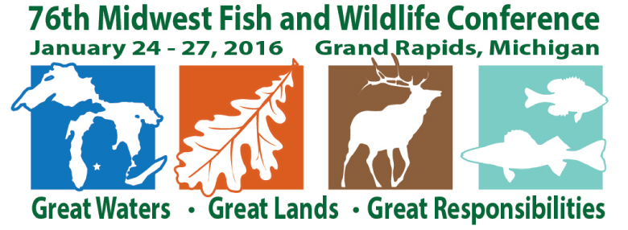

The **76th Midwest Fish & Wildlife Conference** will be held **January 24 - 27, 2016** at the Amway Grand Plaza Hotel in Grand Rapids, Michigan.   
  
The annual conference attracts over 800 biologists and students from state, federal and tribal natural resource agencies across the 13 Midwestern states. Highlights include: over 400 technical presentations, poster displays; including a new digital format, plenary sessions, networking opportunities and social events.

For more information, please visit: http://www.midwestfw.org/index.html

**Conservation Story Telling**

**February 9, 2016, Mandan, North Dakota**

**A WORKSHOP for Natural Resource Professionals**

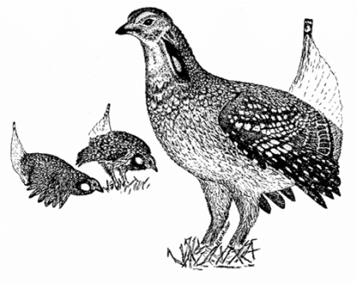**Sponsored by: North Dakota Chapter of The Wildlife Society**

**and other conservation organizations within the State.**

**February 9, 2016, Mandan, North Dakota**

**Session 1 – 9-11:30 a.m.**

**Session 2 – 1-3:30 p.m.**

**Cost – $75/session**

**Attendance limited to 20/session**

**Free STUDENT Seminar – Wednesday February 10, 9-11:30 a.m.**

**These workshops and seminar will provide tips and strategies for the resource professional on how to tell your conservation story more effectively – a must in our competitive society. The student seminar is free and open to all students in the natural resource field of study.**

**The workshops and seminar will be led by Dr. Randy Olson, filmmaker, biologist and author (Don’t be such a Scientist, Connections, Houston we have a story). To reserve a spot, registration information can be found at (ndctws.wordpress.com) or by contacting Mike Olson (**[mikeandhope@bektel.com](mailto:mikeandhope@bektel.com) **or 701-425-7952).**

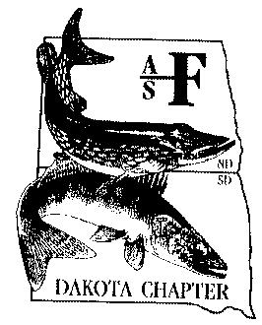**The workshops and seminar will precede the North Dakota Chapter of The Wildlife Society’s 2016 Annual Conference (February 10-12) with the theme,**  **BEYOND BETTER BIOLOGY**, and **will focus on improving the effectiveness of conservation communication by examining a variety of non-traditional disciplines.**

**Financial support was provided by the following:**

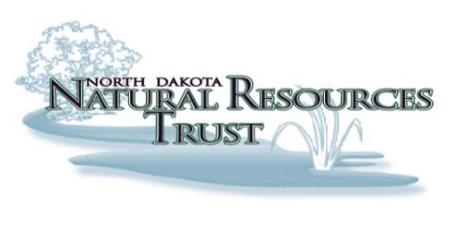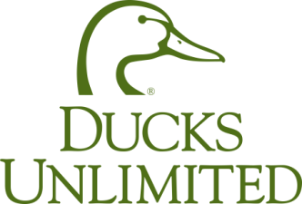

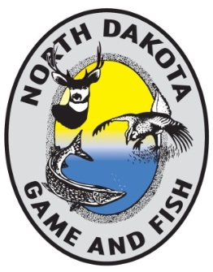

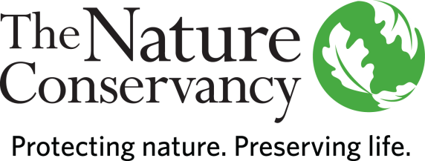

**Randy Olson** (born October 3, 1955) is a scientist-turned-filmmaker who earned his Ph.D. in [Biology](https://en.wikipedia.org/wiki/Biology) from [Harvard University](https://en.wikipedia.org/wiki/Harvard_University) (1984) and became a tenured professor of [marine biology](https://en.wikipedia.org/wiki/Marine_biology) at the [University of New Hampshire](https://en.wikipedia.org/wiki/University_of_New_Hampshire) (1992) before changing careers by moving to Hollywood and entering film school at the [University of Southern California](https://en.wikipedia.org/wiki/University_of_Southern_California). He has written and directed a number of short films and feature documentaries which have premiered at film festivals such as [Tribeca Film Festival](https://en.wikipedia.org/wiki/Tribeca_Film_Festival) and [Telluride Film Festival](https://en.wikipedia.org/wiki/Telluride_Film_Festival). Most of his films draw on his science background, involve humor, and address major science issues such as the decline of the world's oceans, the controversy around the teaching of [evolution](https://en.wikipedia.org/wiki/Evolution) versus [intelligent design](https://en.wikipedia.org/wiki/Intelligent_design), and the attacks on [global warming](https://en.wikipedia.org/wiki/Global_warming) science. He is also the author of three books aimed at helping the science communicate more effectively with the general public. His company, Prairie Starfish Productions, is based at Raleigh Studios in [Hollywood, California](https://en.wikipedia.org/wiki/Hollywood,_California).



**Second NOTICE &**

**CALL FOR PAPERS**

**Hugh C. Becker Muskie Symposium**

**March 13-15, 2016 - - Minnetonka, MN**

Sponsored by MUSKIES, INC. and the

Esocid Technical Committee, North Central Division – AFS

Plan now to attend and present at the Hugh C. Becker Muskie Symposium, to be held March 13 – March 15, 2016, in Minnetonka, Minnesota. Muskellunge researchers, resource managers, and anglers from across North America will gather for three days of technical presentations, poster sessions, panel discussions, and great socials! This symposium will commemorate the 50th Anniversary of Muskies, Inc.!

**Venue:** Presentations and socials will be held at the **Sheridan Minneapolis West, Minnetonka, MN**; double occupancy rooms are $89. Early registration for the meeting will be available **10/15/2015–2/16/2016.** There will be a reduced fee for students. Check Muskiesinc.org for information on arrangements and to register for the meeting.

**PRESENTERS!! Lodging and Registration Fees waived for presenters!!** The proceedings will be published as a peer-reviewed Special Publication with AFS.

**Submit Abstracts for Presentations and Posters** to the Program Technical Committee, c/o:

**Dr. Derek Crane, Coastal Carolina University:** [**dcrane@coastal.edu**](mailto:dcrane@coastal.edu)

Deadline for submission of ABSTRACTS is December 31, 2015.

**See you in the Twin Cities!**

Sheridan Minneapolis West

12201 Riverdale Drive

Minnetonka, MN 55305

(952) 593-0000

**Dakota Chapter Officers, 2015 – 2016**

***President***

Greg Simpson

South Dakota Game, Fish and Parks

4130 Adventure Trail

Rapid City, SD 57702

605-394-6783

[Greg.simpson@state.sd.us](mailto:Greg.simpson@state.sd.us)

***Vice President***

Jill Voorhees

Cleghorn Springs SFH

Hatchery Assistant Manager

605-394-1226

<Jill.voorhees@state.sd.us>

***Secretary/Treasurer***

Jake Davis

South Dakota Game, Fish and Parks

4130 Adventure Trail

Rapid City, SD 57702

605-394-1759

<Jake.davis@state.sd.us>

***President Elect/Newsletter Editor***

Casey Williams

Valley City State University

Valley City, ND 58072

701-845-7457

[casey.williams@vcsu.edu](mailto:casey.williams@vcsu.edu)

***Past-President***

Kurt Eversman

Valley City National Fish Hatchery   
11515 River road  
Valley City, North Dakota

(701) 845 3464

[kurt_eversman@fws.gov](mailto:kurt_eversman@fws.gov)

***SDSU Subunit President***

Chad Kaiser

South Dakota State University

Brookings, SD 57007

605-688-6121

[chad.kaiser@sdstate.edu](mailto:david.deslauriers@sdstate.edu)

***VCSU Subunit President***

Lane Dahl

Valley City State University

Valley City, ND 58072

<Lane.dahl@vcsu.edu>

#### *Standing Committees*

***Planning***

Greg Simpson (chair, SD)  
Kurt Eversman (ND)

***Membership***

Matt Ward (chair, SD)   
Casey Williams (ND)   
Geno Adams (SD)

***Continuing Education***

Dan James (co-chair, SD)  
Greg Power (co-chair, ND)  
John Lott (SD)

Dane Shuman (SD)

***Schmulbach Scholarship***

Wayne Nelson-Stastny (SD)

Zachary Shattuck

***Resolutions***

Chelsey Pasbrig (SD)

Gene Ganinat (SD)

***Awards & Nominations***

Kurt Eversman (chair, ND)

***Environmental Concerns***

Michael Johnson (co-chair, ND)

Geno Adams (co-chair, SD)

***Student Affairs***

***Information & Web Support***

Mike Brown (chair, SD)

Hilary Meyer (SD)