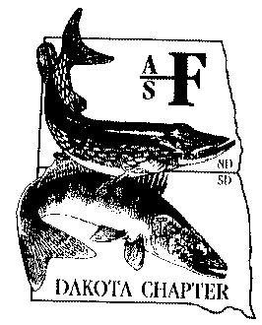
Dakota Chapter
American Fisheries Society
Newsletter
Issue 55 July 2016

g
President’s Message

Highlights in This Issue

President’s Message.........................1

2015 Business & ExComm Meeting minutes……………...……….…..........3

North Dakota Fisheries Update……6

South Dakota Fisheries Update…...8

SDSU Subunit Update…………….…8

VCSU Subunit Update……………...9

Meetings and upcoming events.....10

Chapter contact info……………......12

Greetings Dakota Chapter Members,
For many of us in the Dakota’s the field season is upon us and with it there will be many days away from the office or at least from the computer. As a potential break in the outdoor work I would like to bring everyone’s attention to this year’s Parent Society meeting that will be held in Kansas City on August 21-25, 2016. The close proximity of this meeting can be a great opportunity for those who have never been to a meeting of this size before. We also have several North Central Division meetings that occur during the summer. Contact the Dakota Chapter representative of walleye, centrachid, ictalurid, or esocid if you are interested in their next meeting (http://dakota.fisheries.org/standing-committees/).
The annual Dakota Chapter Meeting seemed to go well this year with participation of 128 members showing high quality posters and papers on their research. We started out the conference with a Continuation Education workshop entitled “Is graduate school for you? A guide for both students and professionals” that was taught by Dan James, Melissa Wuellner, Casey Williams and Dave Lucchesi and attendance by 28 students and other professionals. Opening the Plenary Session was Tom Lang who described how he was brought many diverse groups together to achieve a 50-million dollar holistic revitalization of Lake Wichita in Texas.
Several people were recognized during the Awards Banquet. Those students who received the Sauger Scholarships were: Calvin Rezac, Logan Gutzmer, Chuck Mordhorst and Jenna Haag from the SDSU subunit and Benjamin Holden and Alician VanSweringe from the Valley City subunit. Jenna Haag also received the Dr. James C. Schmulbach Memorial Scholarship. The Alven Kreil award went to Seth Fopma and Cooper Folmer. The student awards culminated with the Robert A. Klumb Memorial Scholarship which was awarded to Dan Nelson. Several professional awards were presented at the 52nd Annual meeting as well. Special recognition awards were given to Matt Ward for his service on the Membership Committee and Hilary Meyer for her work on the Information and Web Support Committee. The Past-President award was given to Kurt Eversman. The Aquatic Resource Conservation Award went to the South Dakota High Plains Anglers Club for their work on Orman Dam and around Belle Fourche, South Dakota. Our Outstanding Young Professional award was presented to Jake Davis and the nights highlight was the Robert Hanten Distinguished Service Award which was given to Jeff Hendrickson. At the end of the meeting, poster and paper judges presented their findings. Special recognition needs to go to Benjamin Schall and Hilary Meyer for their best posters and to Hannah Neumiller, Gretchen Blain and Jill Voorhees for their best paper awards.
I want to thank many people who have helped me through being President of the Dakota Chapter. First, are those who were in the position before me, most notably Kurt Eversman, Dan Dembkowski, and Mike Olsen. Their past experience and suggestions helped me along the way. Second, are those that assisted with this year’s meeting. I can’t name them all as I would surely miss some, but our current Vice President (Jill Voorhees) and Secretary/Treasurer (Jake Davis) are two that I would like to single out. Lastly, is a general thanks for all of the members of the Dakota Chapter. It has been a great run serving those of the Dakota Chapter and it is a period of time that I will cherish in memory for quite some time.
Greg Simpson, President

2016 Spring Business Meeting
Dakota Chapter
American Fisheries Society
February 2, 2016
9:00 AM

G. Simpson called the meeting to order at approximately 3:40 pm. A quorum of members was established.

Officer Reports

President’s Report (Greg Simpson):
G. Simpson mentioned that most of duties involved setting up the meeting, including: location, food, and speaker. He mentioned that there was an issue where the parent society did not have a copy of the Chapters bylaws on file. He also communicated with the NCD.

Vice President’s Report (Jill Voorhees):
J. Voorhees mentioned that she helped when needed and put the agenda together.

Secretary/Treasurer’s Report (Jake Davis):
J. Davis reported that there were 129 paid attendees at the meeting with 33 students, representing five universities and 96 professionals, representing nine agencies. Also, 96 attendees pre-registered using PayPal. The account balances were reported as follows:
Edward Jones:$6401.37
Dakota Chapter checking account: $12,689.10
Dr. James C. Schmulbach account:$10,812.94
Robert A. Klumb memorial fund:$7,212.19

President-Elect’s Report (Casey Williams):
C. Williams stated that he put the fall newsletter together.

SDSU Student Subunit Report (Dan Nelson)
D. Nelson reported that the subunit participated in the Lake Kampeska Izaak Walton Water Resource Festival, fish sampling workshop with “Upward Bound”, fish ID with Brookings Middle School 6th graders, helped with salmon spawning and hosted the walleye and centrarchid technical committee meeting. Additionally, they added a social liaison to their officers, hosted a job fair and resume building workshop, sent members to several meeting, helped with trout restorations and collaborated with the VCSU subunit.

VCSU Student Subunit Report (Lane Dahl):

L. Dahl stated that the subunit had made a push to gain membership through activities including a fishing tournament, salmon fishing, canoe races and game feeds. The subunit has 51 paid members and they participated in other activities including: community Olympics, “pickled fish” project for fish ID at local schools and they are planning a trip to the SE to gain experience.

Committee Reports

Awards and Nominations:
K. Eversmann made mention that he updated the award applications and made a list of past winners and is recruiting for future positions.

Continuing Education:
D. James replaced S. Chipps on the committee and reported that there were 26 attendees at the continuing education workshop.

Membership:
No news to report.

Information:
H. Meyer reported that she updated the website to make it more user-friendly and set up the PayPal account.

Student Affairs:
G. Simpson noted that he worked with including VCSU student sub-unit into the bylaws

Resolutions:
C. Pasbrig noted that no resolutions were brought to the membership.

Scmulbach Scholarship:
W. Sayler noted that there was a winner of the Schmulbach Scholarship and that it would be announced at the banquet.

Environmental Concerns:
G. Adams noted that no environmental concerns were brought forward to the membership in South Dakota, but did not know about North Dakota and M. Johnson was not in attendence.

NCD Tech Committees:

See comments below under “New Business.”

Membership:
No news to report.

Technical Committees:
Walleye tech-M. Fincel mentioned that the walleye tech meeting was held in Brookings, SD during July 21-23, 2015 and that next July it would be in Nebraska.

Centrarchid tech-D. Nelson reported that there were a few centrarchid studies ongoing, but not much else.

Esocid tech-B. Blackwell met in Brookings with the walleye tech and will meet in Minnetonka in March-first in 10 years.

Old Business

S. Chipps motioned for 2 year appointment of secretary/treasurer. B. Blackwell seconded.

W. Saylor mentioned how it would help with consistency and S. Chipps noted the difficulties with moving accounts annually and who to send checks to and a longer term would help. G. Simpson closed discussion and membership passed the motion with all in favor and none opposed.

New Business

B. Blackwell noted that there was a request of funds (~$1,000.00) from each chapter to support publishing the book of the musky symposium. Several chapters had contributed already. B. Blackwell moved for a contribution of $500.00, S. Chipps seconded. There was no discussion and motion passed with all in favor and none opposed.

G. Simpson noted that a request for funds had been submitted by the parent society for the Skinner travel scholarship. W. Saylor motioned for a contribution of $500.00 from the chapter, J. Kientz seconded. There was no discussion and motion passed with all in favor and none opposed.

J. Davis mentioned that there may be need for a second signer on the accounts. Discussion from the floor ensued concerning the need for a second signer with contributions from W. Saylor, M. Ermer, M. Fincel and G. Knecht and that the second signer would be a member would be designated by the secretary/treasurer as long as they were a member in good-standing with the Chapter. L. Pierce motioned that a second signer be added and K. Potter seconded. The motion passed with all in favor and none opposed.

C. Williams noted that there was no mention of the VCSU subunit in the Chapter bylaws. There was discussion on the floor to update the bylaws to include VCSU and that there would be a Sauger Scholarship from SDSU and a separate scholarship, to be named later, from VCSU. W. Saylor requested that C. Williams draft the language for the change in the bylaws and that there would be an electronic vote by the Chapter membership. W. Saylor motioned and L. Dahl seconded. The motion passed with all in favor and none opposed.

G. Simpson requested any business from the floor. K. Potter mentioned that there was substantial funds in the accounts and if there was a way to move money to a new account for increased scholarship opportunities. S. Chipps noted that there had been few applicants for current scholarships. M. Ermer inquired as to the dollar amounts on all scholarships. W. Saylor explained the Schmulbach scholarship. W. Saylor motioned that the Chapter ExComm sets the annual funds for scholarships and K. Potter seconded. The motion passed with all in favor and none opposed.

C. Williams mentioned that there may be other avenues for funds for student travel through donations from MDU, similar to what ND TWS received and inquired as to if he could pursue acquiring similar donations. W. Saylor motioned and Scott Gangle seconded. The motion passed with all in favor and none opposed.

The meeting was adjourned at approximately 4:45 PM.

We can now accept membership dues online via pay pal. Just go to the Dakota chapter AFS website : http://dakota.fisheries.org/membership/ to renew or join today. Any website updates can be sent to: Hilary.Meyer@state.sd.us

North Dakota Fisheries Update

It seems unreal, but spring has already bled into summer with the month of June behind us. Historically, June is the one calendar month when fishing doesn’t disappoint; based on feedback I’ve received, I think that was again the case this year. Thankfully, we still have a lot to offer an angler in quality, quality and even diversity (beyond just walleye!) in the months to come.

As we reach halftime of 2016, it’s a good time to recap the past few months of fisheries staff activities. A very warm winter led to a very early ice-out. Due to poor snowpack and the mild winter statewide, there was essentially no winterkill in North Dakota’s 400-plus fishing lakes. Perhaps record-setting, this is the second consecutive year with very little winterkill statewide.

As always, our crews were anxious to get on the water, and with the early ice-out, spawning nets went in immediately for both northern pike and walleye. Relative to many other years, the needed eggs came easy, resulting in full jar batteries at both of North Dakota federal hatcheries. Most of the pike eggs came from Devils Lake and most of the walleye eggs originated from Lake Sakakawea.

Fisheries staff also trapped and transported adult pike, yellow perch, smallmouth bass, bluegill and channel catfish to lakes in need. This effort, coupled with the annual stocking of 50,000-plus rainbow trout, has been well received across the state. Regarding stocking, all the pike and walleye have been stocked and the hatcheries (far) exceeded requests. Fish production in 2016 was very good.
Also, Lake Audubon received 1,600 nice pure muskie, the sought-after Leech Lake strain. Time will tell if a fishery develops, as Audubon now has been stocked with muskie for a number of years.

More than 4,100 walleye were again tagged in North Dakota’s portion of the Missouri River/ Lake Oahe, bringing the four-year (and final) tally to more than 17,000 fish. This cooperative project with South Dakota Game, Fish and Parks and South Dakota State University has already provided valuable and useful information.

Missouri River System staff also tagged 300-plus adult paddlefish near the confluence of the Yellowstone and Missouri rivers and another 700-plus fish in the Missouri River north of Bismarck. The 2016 paddlefish snagging season was another short one with only four harvest days allowed before the season was closed. Slightly more than 1,000 paddlefish were likely harvested during those four days.

A new aquatic nuisance species (ANS) administrative rule became effective April 1, requiring all plugs be pulled from all watercraft statewide when a boat is transported out of water. Along the lines of ANS, no news is always welcomed news. No new ANS infestations have been documented so far this year (as of July 1). Lastly, Jessica Howell became North Dakota’s new ANS coordinator in February. Jessica is not new to the ANS world and has done a great job continuing the work of Fred Ryckman, who retired earlier this year.

Other than the normal post-winter issues with ice damage to some ramps, 2016 has been manageable for Development staff. Ramps are generally in good shape throughout most of the state, although receding lake levels may accelerate some of this work. The long-term maintenance of 440 public boat ramps will always provide an extensive “to-do” list.
The 2017 Dakota Chapter Annual Meeting will be held in Jamestown, ND from February 21-23 (Tentative). Notification of definitive dates will be sent out soon. If you have any ideas or events you would like to see at the meeting, please contact Casey Williams (casey.williams@vcsu.edu).

For our fish habitat program (Save Our Lakes), some additional funding (outside the Department) was garnered, which will be spent on private property in an effort to protect immediate/downstream fisheries. Easements, alternative water sources, and fencing are popular tools to achieve this goal.

Lastly, statewide district lake test netting (adult populations surveys) is winding down as crews move to the larger waters for survey work. Dry conditions and lower lake levels are becoming a concern.

One field observation that is shared throughout much of the state is that two diametrically opposite events continue to occur on the prairies. Some good fishing lakes have active “drainage” projects ongoing, causing lake declines of 3 to 7 feet. At the same time, new real estate developments supporting camping, or permanent homes/cabins are being built on many other fishing lakes. Challenges abound!

Maybe it’s my half-full outlook, but it sure seems like good fishing awaits most every day of the year. Even though the so-called dog days of August will soon be knocking, some new fishing opportunities await (e.g. give bass a chance)! As always, make it a priority and get out and wet a line.

Submitted by Greg Power

South Dakota Game, Fish and Parks Fisheries Program Update

Chad Haabala was hired this spring as a resource biologist at Blue Dog Lake State Fish Hatchery in Waubay. Originally from Alexandria, MN, he recently graduated with degrees in zoology and sociology from North Dakota State University. He spent three summers as a fisheries management and research intern in west central Minnesota. In his free time he enjoys waterfowl hunting and going bass fishing every chance that he gets. He is very excited to call South Dakota his new home and looks forward to building his career there, as well as starting a family with fiancé, Bobbie.

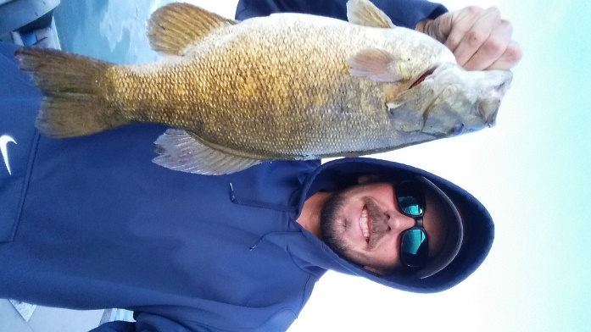
Chad Haabala of the Blue Dog Lake State Fish Hatchery

SDSU AFS Student Subunit Update

Since the annual Dakota Chapter meeting this past winter the SDSU AFS sub-unit has been preparing members for their summer job hunt. We conducted a series of job search and primer exercises which included a job fair, resume workshops, and mock interviews. Employers from six states provided the opportunity to apply for over 100 different jobs during our job fair. This was then followed by a resume writing workshop that was held in conjunction with our Career Services Center at SDSU. Members were then given time to construct their resume and were then put through mock interviews by graduate students and faculty members.

Once students were prepared to apply for jobs, we had representatives from non-governmental organizations, state agencies, and federal agencies come and

describe their everyday and annual job tasks; both pros and cons, to give students a better idea of what each agency is about.
Student members volunteered at a few local events promoting the education of young individuals. It began with Frost Fest 2016, hosted by Dakota Nature Park, where members were just along for the ride helping children learn how to be safe during ice fishing and how to enjoy their time on the ice. Once the ice thawed members were able to partake in the Big Sioux Water Festival. Here members taught 4th graders about how to be “water-wise” and the “Fishes of the Big Sioux River.” Finally the few AFS members were able to find jobs for local fisheries agencies are gearing up to be a part of the Natural Resources Camp hosted by SDSU. High school students will get a first time hands-on experience on how we employ our fisheries techniques as far as lake/stream ecology, field sampling and fish identification.

VCSU AFS Student Subunit Update
The Valley City State University Subunithas continued to be a major success on campus. With more than 30 active members, the student subunit continues to grow and has seen an increase in participation. The current unit president, Lane Dahl and the rest of the officers have been working to create an atmosphere that welcomes both underclassmen and upperclassman at VCSU.

The second year for the VCSU Student Subunit has provided its members with many opportunities to get involved. These opportunities include various events, fundraisers, professional development opportunities, and more.

The early fall provided the subunit many opportunities to get outside and enjoy the weather. To begin the year, the unit hosted events such as the Second Annual Team Fishing Tournament and a canoe race that took place on the Sheyenne River. Although there were not many fishes caught, the club also provided the members an opportunity to go camping and salmon fishing on the Missouri River and Lake Sakakawea. To wrap up the fall semester’s events, a Christmas party was held at Chautauqua Park in Valley City. This was an opportunity for all the members to socialize and discuss the year’s events.

With students returning from winter break, club activity picked up once again. With funds raised the previous semester, the unit was able to provide transportation and room/board for members who wished to attend the AFS Dakota Chapter’s Annual Meeting in Spearfish, South Dakota. The meeting was well attended by the Valley City State Students with 15 in attendance.

After returning from Spearfish, the subunit continued to host events. New events that the club participated in was the North Dakota Winter Show Chili Cook-off and the Valley City Community Olympics that was held during the week of the annual Winter Show. The club assisted with making pineapple chili that was awarded second place in the cooking competition. The Community Olympics was a compilation of competitions in which many members participated.

To finish off the year, the club held an end of the year banquet followed by an individual fishing contest the next morning. The banquet was a chance for the devoted members to come say farewell to the graduating seniors and enjoy lawn games, great food, and raffle prizes.

The past year, the student subunit was exceptional at fundraising. The new year did not disappoint. The club held a ticket raffle that would award three individuals some new ice fishing gear for the upcoming winter months. After raising nearly $4,500 dollars, it is fair to say the club had an extremely successful fundraiser that would allow for more opportunities in the near future. Some of these funds were approved for a $250 donation to the AFS Parent Society Skinner Fund and to support travel of the subunit president to the Annual AFS Parent Society National meeting each year. Additional funds will be used to support student travel to the Dakota Chapter meeting and the newly established annual Northern Pike (NOP) Scholarship.

Lane Dahl, who was elected as the VCSU Student Subunit president for a second consecutive term, will continue to look at increasing membership and club events for the future. Currently the club hopes to continue successful fundraisers, provide more professional development opportunities and social events to attract additional members.

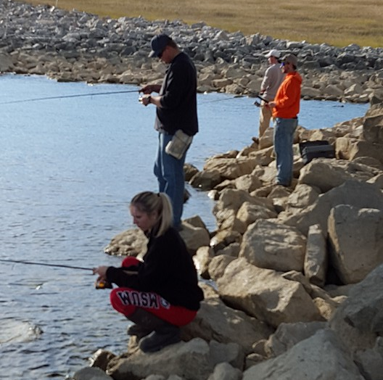
VCSU subunit members salmon fishing

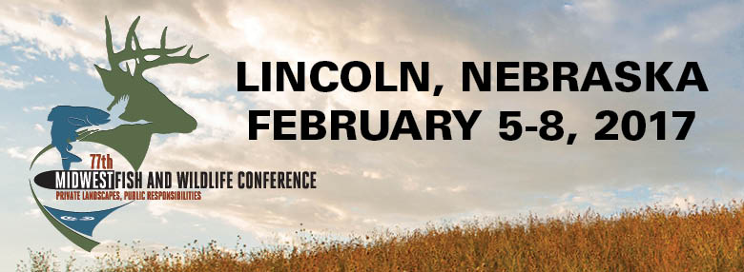

The 77th Midwest Fish & Wildlife Conference will be held February 5 - 8, 2017 at the Lincoln Marriott Cornhusker Hotel in Lincoln, Nebraska.
This annual event will attract over 800 biologists and students from state, federal, and tribal natural resources agencies from the Midwest, Great Plains, Rocky Mountains and Canadian provinces. Highlights include: over 400 technical presentations, poster displays, plenary sessions, networking opportunities and social events.
For more information, please visit: http://www.midwestfw.org/

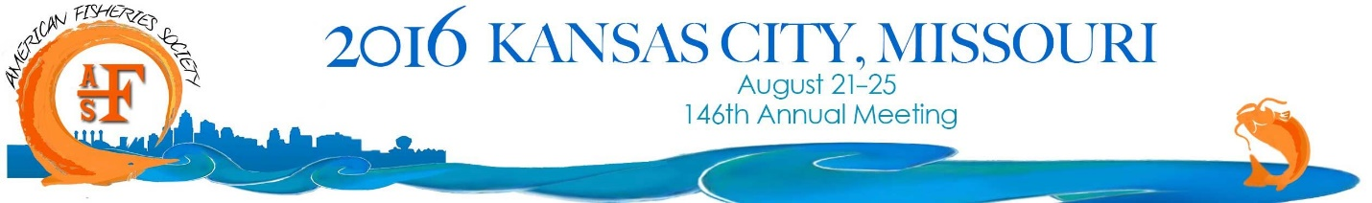

The Missouri Chapter and North Central Division of the American Fisheries Society invite you to attend the 146th AFS Annual Meeting in Kansas City, August 21-25, 2016. This year’s theme is: Fisheries Conservation and Management: Making Connections and Building Partnerships.
The 2016 Annual Meeting offers a chance to present your science to experts from around the world, enhance your job skills with hands-on Continuing Education Workshops, see the latest technology in the Trade Show, and network with colleagues old and new. This year’s hotel and conference center are all under one roof at the Sheraton Kansas City at the Crown Center, giving you more free time to see presentations, meet with collaborators, and explore the city. And Kansas City’s affordable, central location, combined with its thriving arts culture, nightlife, and stunning natural resources, means that there is something for everyone to enjoy in August 2016!

Dakota Chapter Officers, 2015 – 2016

President
Greg Simpson
South Dakota Game, Fish and Parks
4130 Adventure Trail
Rapid City, SD 57702
605-394-6783
Greg.simpson@state.sd.us

Vice President
Jill Voorhees
Cleghorn Springs SFH
Hatchery Assistant Manager
605-394-1226
Jill.voorhees@state.sd.us

Secretary/Treasurer
Jake Davis
South Dakota Game, Fish and Parks
4130 Adventure Trail
Rapid City, SD 57702
605-394-1759
Jake.davis@state.sd.us

President Elect/Newsletter Editor
Casey Williams
Valley City State University
Valley City, ND 58072
701-845-7457
casey.williams@vcsu.edu

Past-President
Kurt Eversman
Valley City National Fish Hatchery
11515 River road
Valley City, North Dakota
(701) 845 3464
kurt_eversman@fws.gov

SDSU Subunit President
Dan Nelson
South Dakota State University
Brookings, SD 57007
605-688-6121
chad.kaiser@sdstate.edu

VCSU Subunit President
Lane Dahl
Valley City State University
Valley City, ND 58072
Lane.dahl@vcsu.edu

Standing Committees

Planning
Greg Simpson (chair, SD)
Kurt Eversman (ND)
Membership
Matt Ward (chair, SD)
Casey Williams (ND)
Geno Adams (SD)
Continuing Education
Dan James (co-chair, SD)
Greg Power (co-chair, ND)
John Lott (SD)
Dane Shuman (SD)

Schmulbach Scholarship
Wayne Nelson-Stastny (SD)
Zachary Shattuck (MT)

Resolutions
Chelsey Pasbrig (SD)
Gene Ganinat (SD)

Awards & Nominations
Kurt Eversman (chair, ND)
Environmental Concerns
Michael Johnson (co-chair, ND)
Geno Adams (co-chair, SD)

Student Affairs

Information & Web Support
Mike Brown (chair, SD)
Hilary Meyer (SD)

